

Jordan University of Science and Technology
College of Computer Sciences & Information Technology

Smart Ride

A project submitted
in partial fulfillment of the requirements for the degree of
Bachelor' in Software Engineering

By

Student Name | Student ID
Ra'ad Diya' AL Rawashdeh | 158228
Kamel Othman Altrablssi | 158638
Mujahed Amer Alzghoul | 156811
Muhannad Radhi Alruwaili | 167947
Nour AlDeen Basem Suleiman Al-Quraan | 158273

Supervised by

Zakarea Mohammad Al-Shara.

Committee Member Names

Committee Member’s First Name Middle Initial Last Name

Committee Member’s First Name Middle Initial Last Name

Month/2026

Undertaking

This is to declare that the project entitled “Smart Ride” is an original work done by undersigned, in partial fulfillment of the requirements for the degree “bachelor’s in software engineering” at Software Engineering Department, College of Computer and Information Technology, Jordan University of Science and Technology.

All the analysis, design and system development have been accomplished by the undersigned. Moreover, this project has not been submitted to any other college or university.

Student 1: Ra'ad Diya' AL Rawashdeh (158228)

Student 2: Kamel Othman Altrablssi (158638)

Student 3: Mujahed Amer Alzghoul (156811)

Student 4: Muhannad Radhi Alruwaili (167947)

Student 5: Nour AlDeen Suleiman Al-Quraan (158273)

ABSTRACT
This project presents a Smart Carpool System that improves transportation efficiency by introducing route segmentation, dynamic pricing, and secure commitment mechanisms. Unlike traditional carpool or booking systems that rely on fixed routes and static pricing, the proposed system divides each trip into multiple segments, allowing passengers to select flexible pickup and drop-off points while enabling efficient seat reuse.
The system incorporates a commitment model with minimum passenger requirements, a check-in mechanism, and a no-show handling policy to enhance reliability. Additionally, a simulated escrow-based payment system ensures secure transactions between drivers and passengers.
The application is developed using Flutter for the front end and Laravel API for backend services, supported by a relational database. The proposed solution aims to reduce seat waste, improve trust, and provide a more flexible and dependable transportation experience.

Acknowledgment
We would like to express our sincere gratitude to everyone who supported and guided us throughout the development of this graduation project.
First and foremost, we would like to thank our supervisor for the valuable guidance, continuous support, and constructive feedback provided during all stages of the project. Their advice and encouragement greatly contributed to the successful completion of this work.
We also extend our appreciation to the faculty members of the Software Engineering Department at Jordan University of Science and Technology for the knowledge and skills they provided throughout our academic journey.
Special thanks go to our families and friends for their patience, motivation, and continuous encouragement during the project period.
Finally, we would like to thank everyone who contributed directly or indirectly to the completion of the Smart Ride project.
Content

Undertaking 2
ABSTRACT 3
Acknowledgment 4
CHAPTER 1: Project Overview, Vision, and Planning 1
1.1 Problem Statement 1
1.2 Related Products 1
1.3 Product Vision 3
1.4 Project Objectives and Milestones 3
1.5 Risk Assessment and Mitigation 4
CHAPTER 2: Product Features and Requirements 6
2.1 Functional Features 6
2.2 Feature-to-Requirement Mapping 9
CHAPTER 3: System Design and Deployment Overview 15
3.1 System Architecture 15
3.2 Detailed Design (UML Models Based on Implementation) 15
3.3 Software Deployment 19
CHAPTER 4: System Development and Implementation 20
4.1 Core Implementation Progress 21
4.2 Implemented and Planned Features 21
4.3 Screenshots Evidence 23
CHAPTER 5: Testing 24
5.1 Testing Overview 25
5.2 Sample Test Cases 25
5.3 Test reports 26
References 28

Table Of content (Figure)

Figure 1. Context Diagram 3
Figure 2. Gantt Chart 4
Figure 3. Use case Diagram - Driver 10
Figure 4. Use case Diagram - Passenger 11
Figure 5. Use case Diagram - Admin 12
Figure 6. Component Diagram 15
Figure 7. Class Diagram 16
Figure 8. Sequence Diagram - Login 17
Figure 9. Sequence Diagram - Booking 18
Figure 10. State Machine - Booking 19
Figure 11. State Machine - Login 19
Figure 12. UI 23
Figure 13. UI 24

Table Of content (Tables)

Table 1. Related Products 2
Table 2. Milestones 4
Table 3. Risk Assessment and Mitigation 5
Table 4. Functional Requirement (Passenger) 7
Table 5. Functional reequipment (Driver) 9
Table 6. Functional requirement (Admin) 9
Table 7. Non-Functional requirment 14
Table 8. Software Deployment 20
Table 9. Implemented and Planned Features 22
Table 10. Testing tools 25
Table 11. Test cases sample 26

CHAPTER 1: Project Overview, Vision, and Planning

1.1 Problem Statement
Modern transportation systems, especially carpooling and ride-sharing platforms, face several practical challenges that reduce their efficiency and reliability. Most existing solutions rely on fixed routes and predefined pickup and drop-off points, which limits flexibility for users and does not reflect real-world travel needs. As a result, many potential passengers are unable to find suitable rides that match their exact locations.
Another major issue is inefficient seat utilization. In traditional systems, a seat is reserved for the entire trip, even if the passenger only travels a portion of the route. This leads to wasted capacity and reduces the overall effectiveness of shared transportation.
In addition, there is a lack of trust and commitment between drivers and passengers. Ride cancellations and no-show situations are common, with no strict mechanisms to enforce accountability. This creates uncertainty and negatively impacts user experience. Furthermore, pricing models in many systems are either fixed or not fairly distributed based on distance, leading to dissatisfaction among users.
Current systems also lack secure and structured payment handling, increasing the risk of disputes between users. Without proper verification and rating mechanisms, safety and trust remain major concerns.
Therefore, there is a need for a smarter carpool system that provides flexible routing, fair pricing, efficient seat management, and reliable commitment enforcement to improve the overall transportation experience.

1.2 Related Products
Feature | Uber / Careem | BlaBlaCar | Smart-Ride
Route type | Direct point-to-point trips | Fixed long-distance routes | Segmented routes with multiple flexible stops
Pickup / Drop-off flexibility | Limited to selected locations | Limited to predefined meeting points | Flexible pickup and drop-off between route stops
Pricing model | Dynamic pricing based on demand and traffic | Mostly fixed/manual pricing by driver | Dynamic pricing based on selected trip segments
Multiple passengers | Limited ride-sharing support | Supports multiple passengers | Optimized seat usage using segment logic
Check-in system | Not available | Not available | Passenger check-in before trip departure
Payment | Direct in-app payment | Direct payment between users | Escrow-based payment simulation with trip confirmation
Seat Management | Standard seat reservation | Standard seat reservation | Smart seat reuse across different trip segments
Driver Verification | Basic verification | Profile verification | Driver document verification and approval
Trip Segmentation | Not supported | Not supported | Fully supported with stop-based booking
Booking system | Full trip booking | Full trip booking | Partial route booking between stops
Table 1. Related Products

1.3 Product Vision
The proposed system aims to develop a Smart Carpool Platform that enhances daily transportation by introducing flexibility, efficiency, and reliability into shared mobility. The system allows drivers to create trips with multiple stops, while passengers can select convenient pickup and drop-off points along the route. By dividing routes into segments, the system enables dynamic pricing based on distance and optimizes seat usage by allowing multiple passengers to share the same seat across different parts of the journey.
The target users of this system include daily commuters such as students, employees, and individuals seeking affordable and reliable transportation, as well as drivers who want to share their trips and reduce travel costs. The system also benefits the community by reducing traffic congestion and improving resource utilization.

Stake Holders:

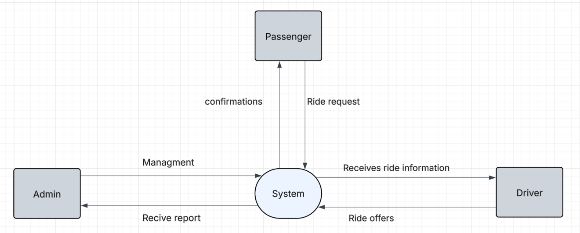
Figure 1. Context Diagram
Product Vision Statement:
“Our system helps commuters achieve flexible, cost-efficient, and reliable transportation by providing a smart carpool platform based on route segmentation, dynamic pricing, and commitment enforcement.”
The value of this project lies in its ability to solve real-world transportation challenges through intelligent system design rather than simple booking functionality. Unlike existing solutions, it introduces a structured commitment mechanism, secure payment handling, and smart seat management, ensuring better user experience and trust.
The system scope includes trip creation, booking, pricing, check-in, and payment management. Advanced features such as real-time tracking and full-scale payment integration may be considered for future development.

1.4 Project Objectives and Milestones
Milestone ID | Milestone Description | Start Date | End Date | Deliverable
M1 | Planning | Week 1 | Week 2 | Planning the main idea of project
M2 | Gather requirement | Week 2 | Week 3 | Get the functional and nonfunctional requirement
M3 | Project Architecture | Week 3 | Week4 | Plan the architecture of the project
M4 | Building UI | Week 4 | Week 5 | Build the UI
M5 | Implementation | Week 5 | Week 11 | Implement the project
M6 | Testing | Week 11 | Week 12 | Test the implemented project
Table 2. Milestones
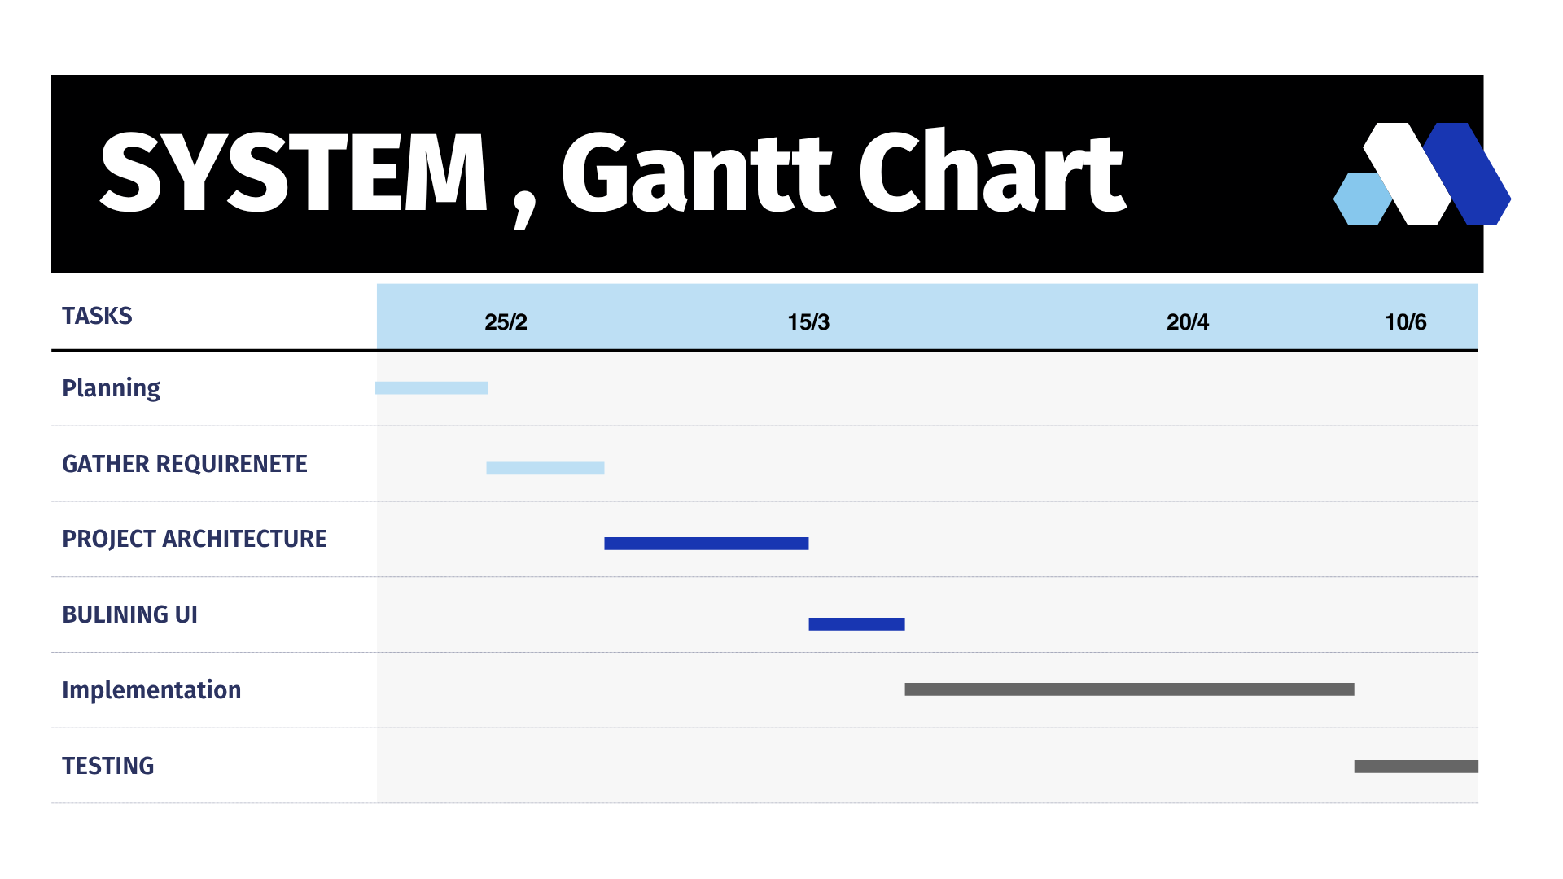
Figure 2. Gantt Chart

1.5 Risk Assessment and Mitigation
Risk ID | Description | Impact | Mitigation Strategy
R1 | Difficulty managing time and completing tasks within the planned schedule (Time Risk). | High | Create a weekly work plan, use a task-tracking tool, and review progress with the supervisor regularly.
R2 | Technical issues such as server crashes, network failures, or system errors. | High | Use reliable hosting, perform regular backups, conduct early testing, and apply error-handling mechanisms.
R3 | Loss of project files or data due to device malfunction or viruses. | High | Use cloud storage (Google Drive / GitHub), maintain regular backups, and use updated antivirus software.
R4 | Integration issues between the mobile app and backend API. | High | Adopt automated API documentation using Swagger / L5-Swagger to keep the Laravel backend contract in sync with the Flutter client; test each endpoint early using Postman, integrate features step by step, and log all errors.
R5 | Changes in project requirements that may affect plans, timeline, or costs. | Medium | Document requirements clearly, get early approval from the supervisor, and limit major changes after development begins.
R6 | Difficulty achieving the defined project goals, which may lead to incomplete or weak system performance. | Medium | Set realistic objectives, follow the design phase clearly, and perform continuous reviews and testing.
R7 | Failure to meet user needs, resulting in low acceptance or dissatisfaction. | Medium | Conduct user feedback sessions, keep the UI simple, and ensure the system meets the core requirements.
R8 | Discovering defects and unexpected bugs after delivery. | Medium | Perform thorough testing, create a bug list, fix issues before final submission, and run user acceptance tests.
Table 3. Risk Assessment and Mitigation

CHAPTER 2: Product Features and Requirements

2.1 Functional Features

The Smart Carpool System is built around five core functional features. Each feature represents a distinct capability that directly supports the system’s goals of flexible routing, fair pricing, and reliable commitment enforcement.

A UML Use Case diagram illustrating interactions between drivers, passengers, and the system will be added in the final submission. The table below summarizes the features:
Feature ID | Feature Name | Description | Priority (H/M/L) | Implementation Stage
F1 | User Authentication | System shall allow users to register and log in securely | High | Project 1
F2 | Search trip | The system shall allow the passenger to search for available trips based on location and time. | High | Project 1
F3 | Pickups point | The system shall display trips with available pickup and drop-off stops. | High | Project 1
F4 | Select pickup points | The system shall allow the passenger to select pickup and drop-off points from available stops. | High | Project 1
F5 | Calculate price | The system shall calculate and display the trip price based on selected segments. | High | Project 1
F6 | Seat bookings | The system shall allow the passenger to book a seat on a trip. | High | Project 1
F7 | View bookings | The system shall allow the passenger to view booking details and trip status. | High | Project 1
F8 | Cancel bookings | The system shall allow the passenger to cancel a booking before the allowed time. | Medium | Project 1
F9 | Check-in bookings | The system shall allow the passenger to check in before trip departure. | High | Project 1
F10 | Trips notifications | The system shall notify the passenger about trip confirmation or cancellation. | Medium | Project 1
F11 | Driver rate | The system shall allow the passenger to rate the driver after trip completion. | Medium | Project 1
F12 | Refund | The system shall allow the passenger to receive refunds in case of trip cancellation or driver no-show. | High | Project 1
Table 4. Functional Requirement (Passenger)

Feature ID | Feature Name | Description | Priority (H/M/L) | Implementation Stage
F1 | User Authentication | System shall allow users to register and log in securely | High | Project 1
F2 | Upload documents | The system shall allow the driver to upload verification documents (license, insurance). | High | Project 1
F3 | Trip creation | The system shall allow the driver to create a trip with origin, destination, and multiple stops. | High | Project 1
F4 | Add trip information | The system shall allow the driver to define available seats and minimum passengers. | High | Project 1
F5 | Trip segments | The system shall automatically divide the trip into segments based on stops. | High | Project 2
F6 | View passengers | The system shall allow the driver to view all passengers who booked the trip. | High | Project 2
F7 | Start trip | The system shall allow the driver to start and complete a trip. | High | Project 2
F8 | Check-in passengers | The system shall allow the driver to check in before trip departure. | High | Project 2
F9 | Receive payment | The system shall allow the driver to receive payment after trip completion. | High | Project 2
F10 | Trips notifications | The system shall notify the driver when the trip reaches minimum passengers. | Medium | Project 2
F11 | Cancel trips | The system shall allow the driver to cancel a trip before confirmation. | Medium | Project 2
Table 5. Functional reequipment (Driver)
Feature ID | Feature Name | Description | Priority (H/M/L) | Implementation Stage
F1 | User Authentication | System shall allow users to register and log in securely | High | Project 1
F2 | Management users | The system shall allow the admin to view all users (drivers and passengers). | High | Project 1
F3 | Management users | The system shall allow the admin to approve or reject driver verification requests. | High | Project 1
F4 | Management trips | The system shall allow the admin to monitor all trips and bookings. | High | Project 1
F5 | Management payment | The system shall allow the admin to view payment transactions. | High | Project 2
F6 | Management reports | The system shall allow the admin to handle user reports and complaints. | Medium | Project 2
F7 | Management users | The system shall allow the admin to suspend or deactivate users if necessary. | Medium | Project 2
F8 | Management statistics | The system shall allow the admin to view system statistics and usage data. | Medium | Project 2
Table 6. Functional requirement (Admin)

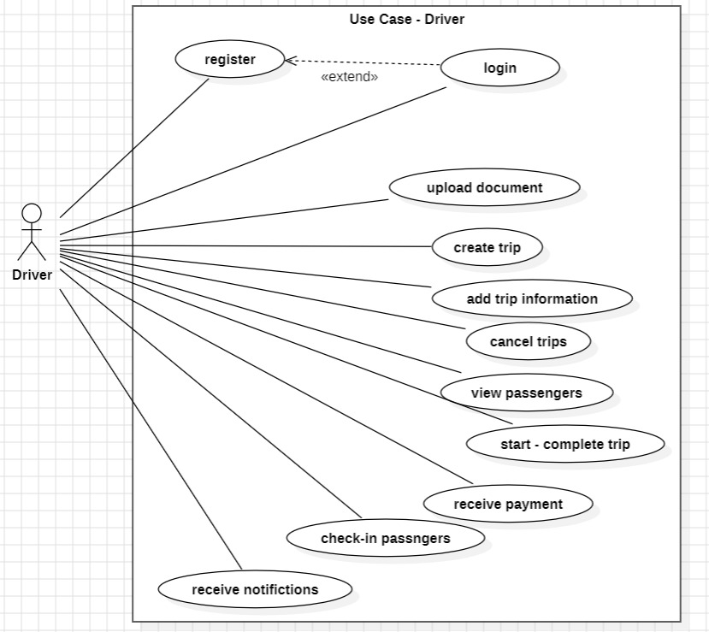
Figure 3. Use case Diagram - Driver

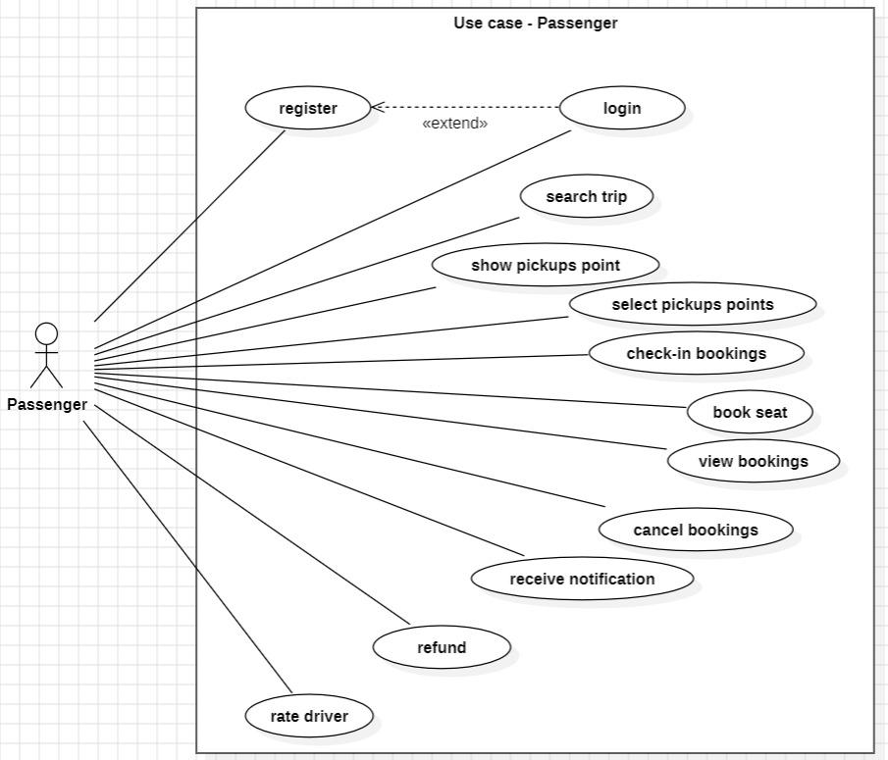
Figure 4. Use case Diagram - Passenger

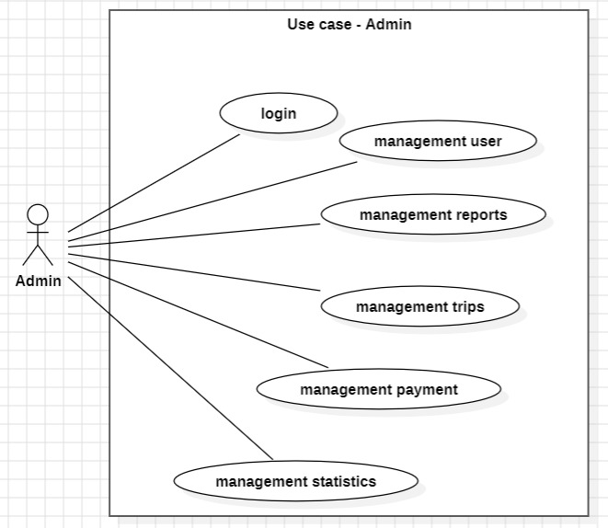
Figure 5. Use case Diagram - Admin

2.2 Feature-to-Requirement Mapping
Feature ID | Requirement ID | Requirement Description | Priority
F1 | FR-1 | The system shall allow users to register using an email and password. | High
F1 | FR-2 | The system shall verify user credentials (email and password) before granting access. | High
F1 | NFR-1 | All user passwords must be stored securely using hashing (e.g., bcrypt). | High
F2 | FR-3 | The system shall allow a driver to create a trip by specifying a route with at least two stops (origin and destination) and available seats. | High
F2 | FR-4 | The system shall allow a passenger to book a seat on a trip by selecting a pickup stop and a drop-off stop along the route. | High
F2 | NFR-2 | Trip search and booking results must load within 3 seconds under normal network conditions. | Medium
F2 | FR-9 | The system shall divide each trip into multiple segments based on the defined stops. High | Medium
F2 | FR-10 | The system shall determine the correct sequence of stops to ensure valid pickup and drop-off selection. High | Meduim
F2 | FR-11 | The system shall map each booking to the corresponding segments between pickup and drop-off points. High | Medium
F3 | FR-5 | The system shall automatically calculate the fare for each booked segment based on the distance between the selected pickup and drop-off stops. | High
F4 | FR-6 | The system shall allow a passenger to check in before trip departure. The trip shall only proceed if the minimum number of passengers (as set by the driver) have checked in. | High
F4 | FR-7 | If a passenger does not check in before the departure deadline, the system shall mark them as a no-show and release their booked seat. | Medium
F5 | FR-8 | The system shall simulate an escrow payment: passenger payment is held by the system and released to the driver only after the trip is completed successfully. | Medium
F5 | NFR-3 | All payment transactions must be recorded in the database with a timestamp, amount, and status (held, released, or refunded). | Medium
System | NFR-4 | Availability: The system shall maintain a minimum uptime of 99.5% on a monthly basis, with planned maintenance windows scheduled during off-peak hours and automatic failover for critical backend services. | High
System | NFR-5 | Usability: The mobile application shall comply with WCAG 2.1 Level AA accessibility standards, including sufficient color contrast, scalable text, and screen-reader compatibility, and shall support both Arabic and English interfaces. | Medium
Table 7. Non-Functional requirment

CHAPTER 3: System Design and Deployment Overview

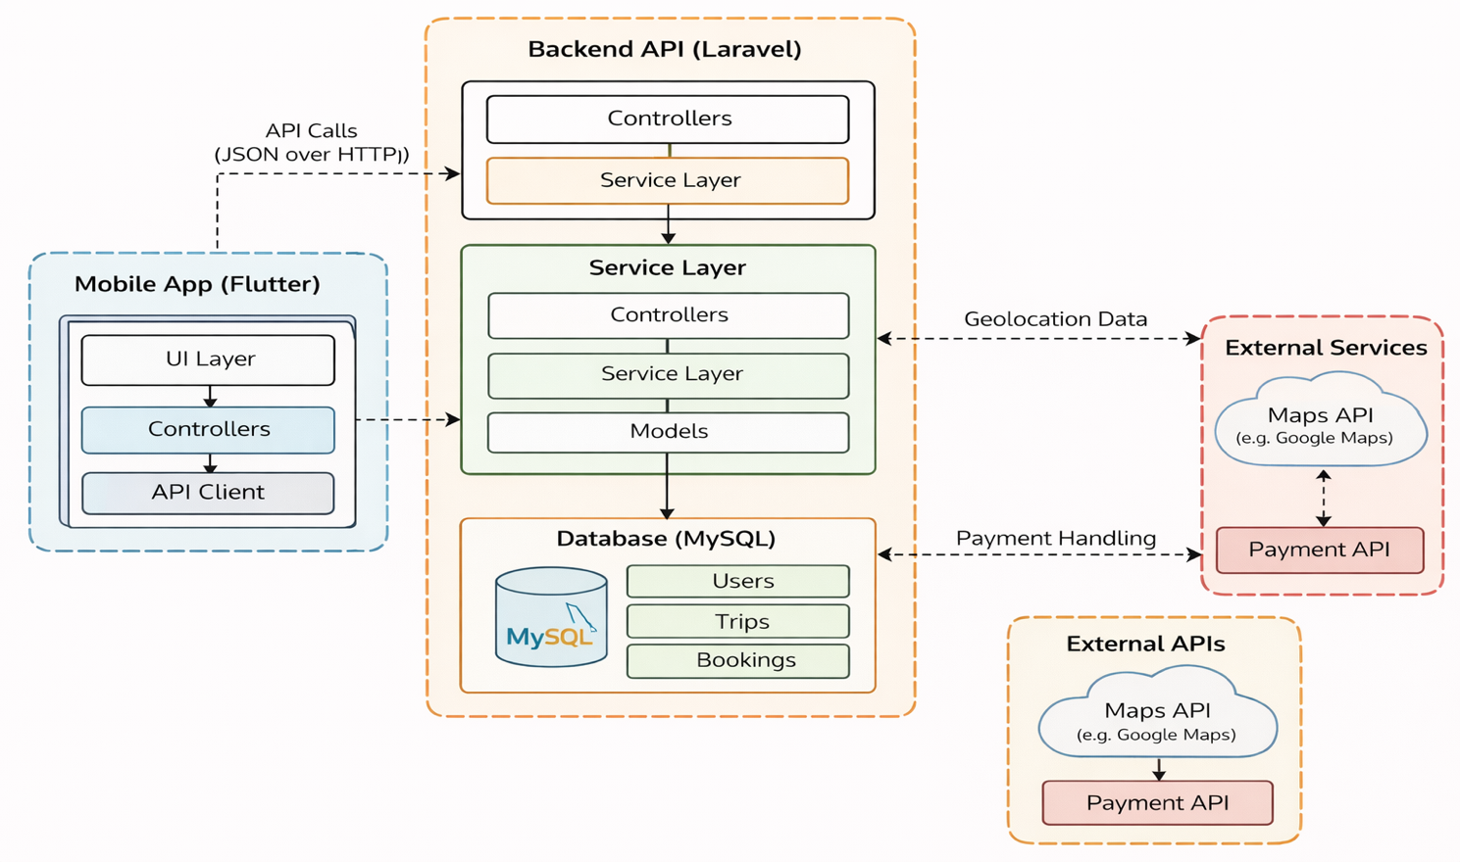
3.1 System Architecture
Figure 6. Component Diagram
The component diagram presents the high-level architecture of the Smart Carpool System. It consists of a Flutter mobile application that communicates with a Laravel backend API. The backend includes controllers and a service layer responsible for core logic such as route segmentation, pricing, seat management, and commitment handling. The system uses a MySQL database to store users, trips, bookings, and payments. External services such as map APIs support route visualization, while payment handling is simulated through an internal escrow mechanism. This design ensures clear separation between presentation, logic, and data layers.

3.2 Detailed Design (UML Models Based on Implementation)

Class Diagram :

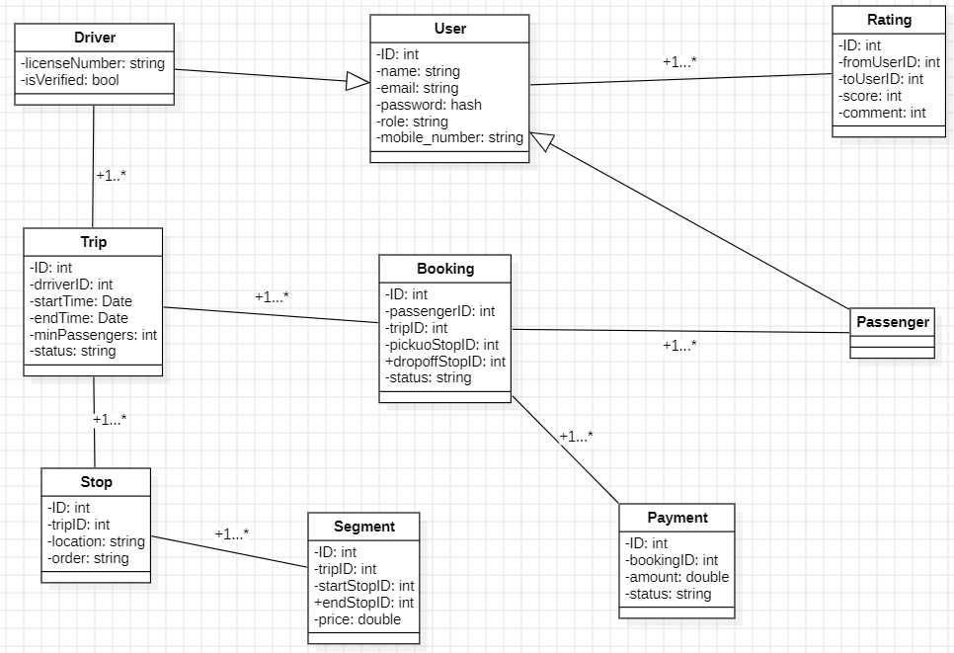
Figure 7. Class Diagram
The class diagram illustrates the main entities of the Smart Carpool System and their relationships. It includes classes such as User, Driver, Passenger, Trip, Stop, Segment, Booking, Payment, and Rating. The User class is extended by Driver and Passenger. A driver creates trips, which contain stops and segments, while passengers create bookings linked to specific segments. Each booking is associated with a payment. The Segment class enables route division, supporting dynamic pricing and efficient seat management. The Rating class stores a numeric score (score: int, 1–5) together with an optional textual review (comment: string) written by the passenger. Relationships between classes ensure proper system functionality and data organization.

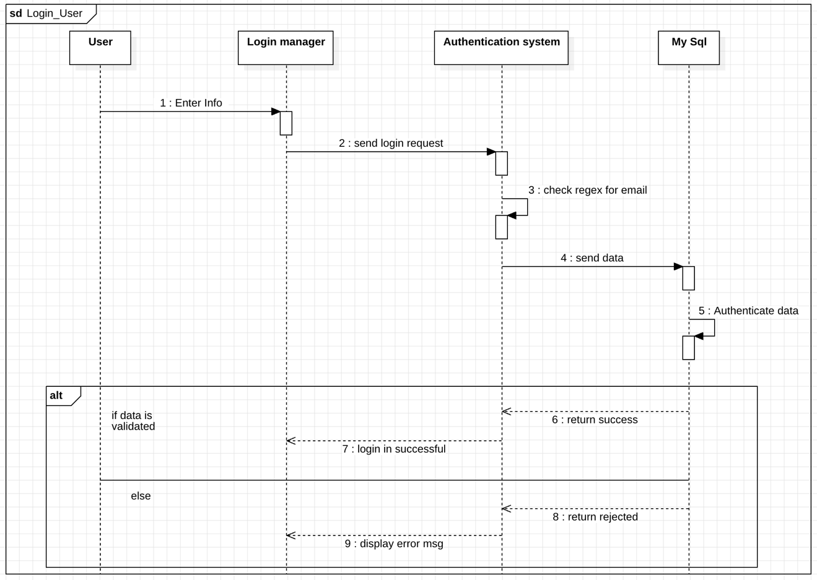
Sequence Diagrams :
Figure 8. Sequence Diagram - Login

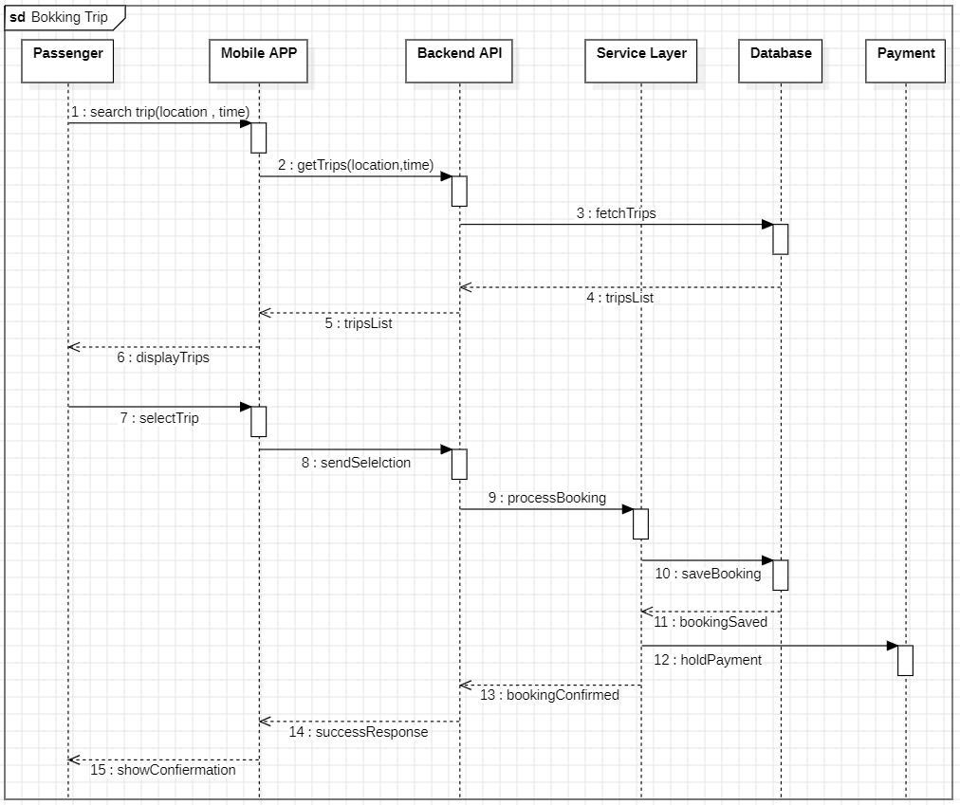
Figure 9. Sequence Diagram - Booking

State Machine Diagram:
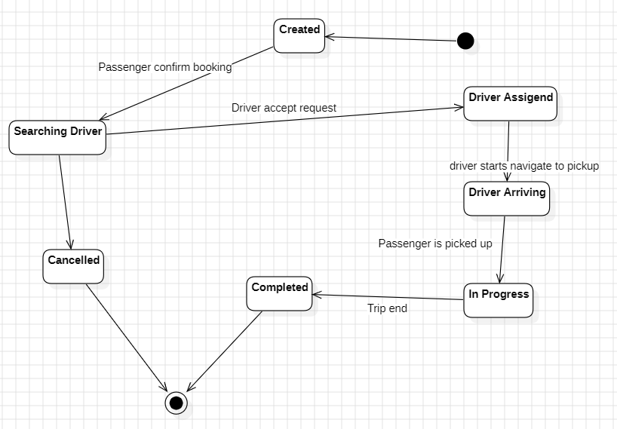
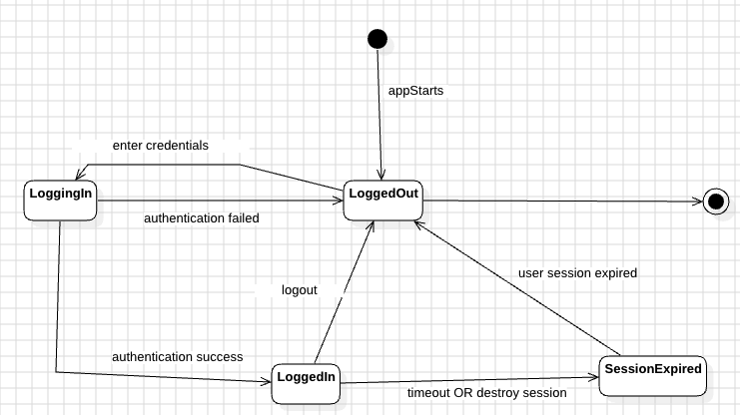
Figure 10. State Machine - Booking
Figure 11. State Machine - Login

Booking Sequence Diagram – layered flow: The booking sequence follows the standard Laravel layered architecture. The Flutter client invokes a Controller, which delegates business rules to the Service Layer. The Service Layer does not access the database directly; instead, it interacts with Eloquent Models / Repositories that encapsulate the data-access logic, and only the Models / Repositories communicate with the MySQL database. This separation keeps controllers thin, isolates persistence details, and makes the booking, segment, and payment logic easier to unit-test.
Booking State Machine – cancellation paths: In addition to the “Searching Driver → Cancelled” transition, the booking state machine supports two further cancellation paths to reflect real-world operations: (1) once a driver has been assigned, the driver may cancel the trip, moving the booking from “Driver Assigned” to “Cancelled (by Driver),” which automatically triggers a passenger refund and releases the booked seats; and (2) during an active ride, the passenger may cancel from “In Progress” to “Cancelled (Emergency)” in case of emergency, which stops the trip, records the partial segments completed, and forwards the case to admin review for partial refund handling.

3.3 Software Deployment
Component | Technology | Purpose
Front-End | Flutter framework | Used to build the mobile application for Android and iOS with a single codebase. Provides fast UI development, smooth animations, cross-platform support, and native performance.
Back-End | PHP Laravel Framework | Handles all server-side logic such as authentication, reservations, garage management, and API creation. Provides routing, middleware, security, and MVC architecture for clean backend development.
Database | MySQL | Stores all application data including users , drivers , trips , passengers , availability, and history. Reliable, scalable, and widely supported relational database.
Dev Tools | Github, Android studio, VS Postman | Main IDE for testing and running the Flutter mobile app on Android emulators and physical devices. Helps debug and profile mobile app performance.
Table 8. Software Deployment

CHAPTER 4: System Development and Implementation

4.1 Core Implementation Progress
The Smart Ride system has been partially implemented to demonstrate the feasibility of the proposed architecture and key functionalities. The development focused on building a working prototype that covers the main user interactions between passengers and drivers.
The front-end mobile application was developed using Flutter, providing a responsive and user-friendly interface. The backend was implemented using the Laravel framework, exposing RESTful APIs to handle authentication, trip management, booking operations, and payment simulation.
So far, the following core modules have been successfully developed:
- User authentication (registration and login)
- Trip search functionality
- Display of available pickup and drop-off points
- Booking system based on selected segments
- Basic check-in mechanism
- Initial payment simulation logic
These components collectively demonstrate the core idea of the system, especially the segmented route concept and dynamic booking logic, which are central to the project.
The project source code is maintained using GitHub for version control and collaboration:
GitHub Repository: Click Here

4.2 Implemented and Planned Features

Feature ID | Feature Name | Related Requirement | Implementation Status | GitHub Link
F1 | User Authentication | FR-01,FR-02 | Implemented | [Link]
F2 | Serach Trip | FR-03 | Implemented | [Link]
F3 | Select Pickup/Drop-off | FR-04 , FR-10 | Partial | [Link]
F4 | Price Calculation | FR-05 | To-be-implemented-GP2 | -
F5 | Seat Booking | FR-04,FR-11 | To-be-implemented-GP2 | -
F6 | View Bookings | FR-07 | To-be-implemented-GP2 | -
F7 | Check-in System | FR-06 | To-be-implemented-GP2 | -
F8 | Trip Creation (Driver) | FR-03 | To-be-implemented-GP2 | -
F9 | Trip Segmentation Logic | FR-09 | To-be-implemented-GP2 | -
F10 | Payment (Escrow Simulation) | FR-08 | To-be-implemented-GP2 | -
F11 | Notifications | - | To-be-implemented-GP2 | -
F12 | Rating | - | To-be-implemented-GP2 | -
Table 9. Implemented and Planned Features

4.3 Screenshots Evidence
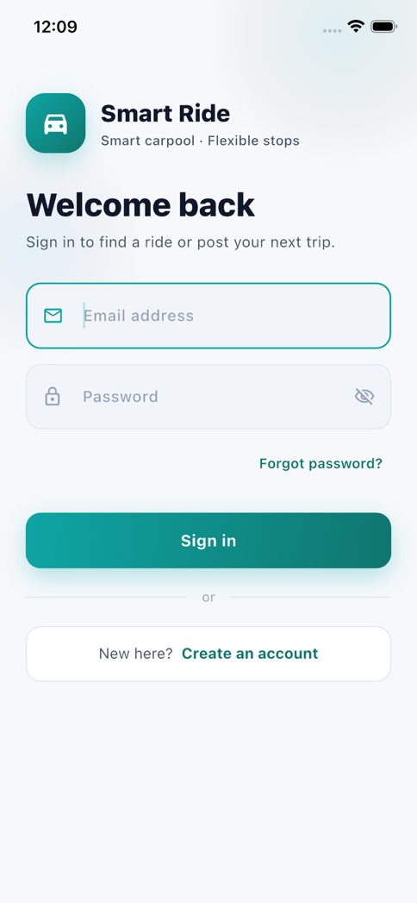
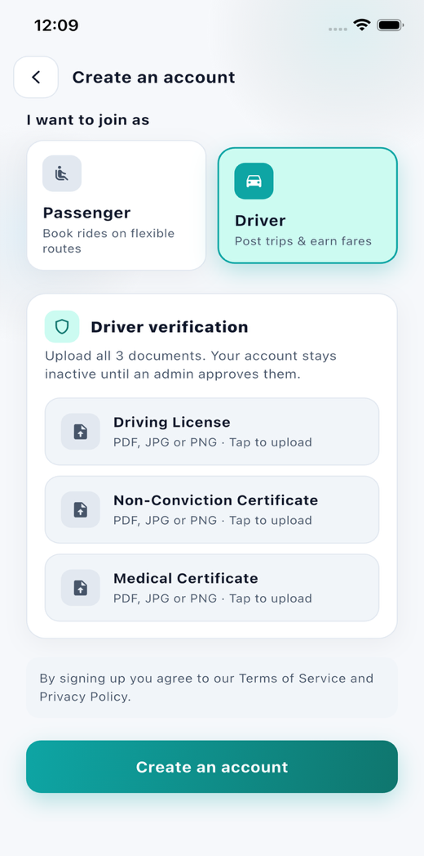
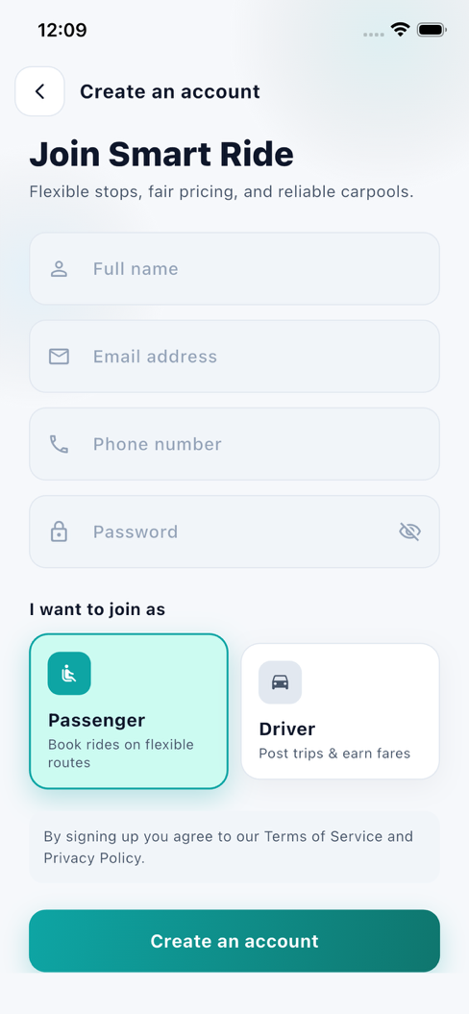
Figure 12. UI

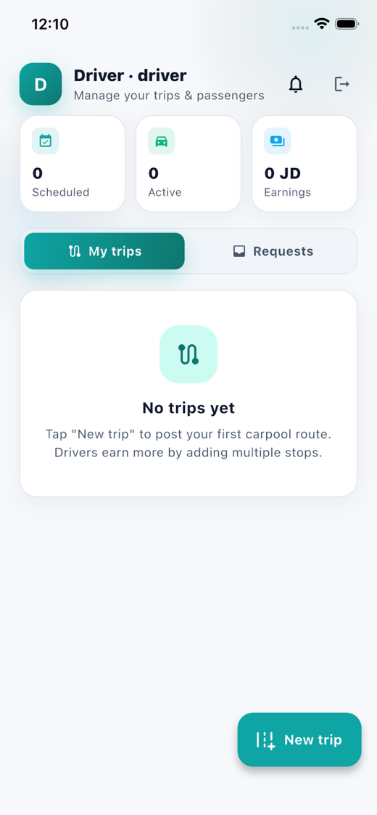
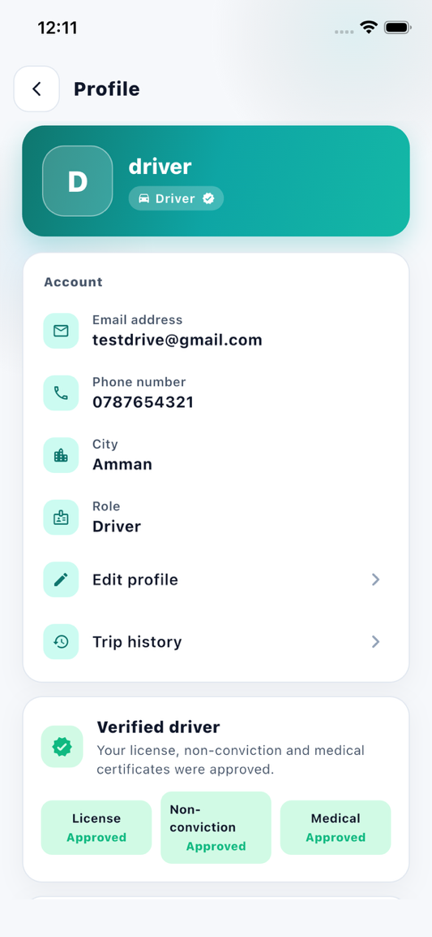
Figure 13. UI

CHAPTER 5: Testing

5.1 Testing Overview
Testing was performed to ensure that the Smart Ride system functions correctly, securely, and reliably. The testing process focused on verifying the implemented features, validating user inputs, ensuring proper communication between the Flutter mobile application and Laravel backend API, and detecting functional or logical errors.
Several types of testing were conducted during the development phase:
- Functional Testing:
Used to verify that each system feature behaves according to the specified requirements.
- API Testing:
Conducted to ensure that Laravel API endpoints return correct responses and handle requests properly.
- UI Testing:
Performed to confirm that the mobile application screens display correctly and provide a smooth user experience.
- Integration Testing:
Used to verify successful communication between the Flutter frontend and Laravel backend.
The testing process covered the following modules:
- User Authentication
- Trip Search
- Pickup and Drop-off Selection
- Trip Booking
- Dynamic Price Calculation
- Driver Trip Creation
- Rating System
- Contact Us Feature
The following tools and frameworks were used during testing:
Tool / Framework | Purpose
Flutter Debugger | Front-end debugging
Postman | API testing
Android Studio Emulator | Mobile application testing
MySQL phpMyAdmin | Database validation
Laravel Logs | Backend error tracking
Table 10. Testing tools

5.2 Sample Test Cases
Test Case ID | Feature | Input | Expected Output | Actual Output | Result | Evidence
TC-01 | Login | Valid credentials | Redirect to dashboard | Dashboard loads | Pass | [Github Link]
TC-02 | Login | Invalid password | Error message displayed | Error message displayed | Pass | [Github Link]
TC-03 | Trip Search | Search for trips from Irbid to Amman | Available trips displayed | Trips displayed correctly | Pass | [Screenshot]
TC-04 | Pickup Selection | Select invalid destination before pickup point | Validation message displayed | Validation worked correctly | Pass | [Screenshot]
TC-05 | Dynamic Pricing | Select Irbid → Jarash segment | Price displayed as 3 JD | Correct price displayed | Pass | [Screenshot]
TC-06 | Dynamic Pricing | Select Irbid → Amman segment | Price displayed as 5 JD | Correct price displayed | Pass | [Screenshot]
TC-07 | Seat Booking | Book available seat | Booking saved successfully | Booking completed successfully | pass | [Screenshot]
TC-08 | Driver Rating | Submit 5-star rating | Rating saved successfully | Rating saved correctly | Pass | [Screenshot]
TC-09 | Contact Us | Send support message | Message saved successfully | Message saved successfully | Pass | [Screenshot]
TC-10 | Driver Trip Creation | Add trip with stops and segment prices | Trip created successfully | Trip stored successfully | Pass | [Screenshot]
Table 11. Test cases sample

5.3 Test reports
The implemented features were tested using multiple testing methods to ensure system reliability and correctness. API requests were tested using Postman, while the Flutter mobile application was tested on Android emulators and physical devices.
Screenshots of the following test results were collected:
- Successful login and registration
- Trip search results
- Booking confirmation
- Dynamic price calculation
- Driver trip creation
- Contact Us submission
- Rating submission
- API response validation in Postman
The test reports confirmed that the implemented modules function correctly and satisfy the specified functional requirements.

References
List all frameworks, APIs, libraries, and research papers used.

